Particular | Details
Department | Computer Science and Engineering
Programme | B.E. / B.Tech. – Computer Science and Engineering
Course Code & Course Name | ITA0605 – Machine Learning
Academic Year / Batch | 2026–2027
Faculty Name | Dr NATTAR KANNAN
Assignment Title | Intelligent Healthcare Diagnosis and Patient Risk Prediction System Using Machine Learning
Date of Issue
Date of Submission | 02/09/2026
Maximum Marks | 100
Course Outcome(s) – CO | CO1: Acquire a foundational understanding of key machine learning concepts including version spaces, candidate elimination, inductive bias, and heuristic search.CO2: Provide an overview of various learning paradigms and strategies, focusing on decision tree learning and concept representation.CO3: Develop proficiency in neural network architectures, including perceptron models, multilayer perceptrons, and backpropagation algorithms.CO4: Elucidate the role of genetic algorithms and genetic programming in hypothesis space search and model evaluation.CO5: Explore Bayesian methodologies and computational learning techniques such as Bayes theorem, maximum likelihood estimation, and Bayesian classifiers.
Bloom's Taxonomy Level | L3 – Apply; L4 – Analyse; L5 – Evaluate; L6 – Create
SDG Mapping (SDG 1–17) | SDG 3 – Good Health and Well-BeingSDG 9 – Industry, Innovation and InfrastructureSDG 10 – Reduced Inequalities
Industry / Societal Relevance | Directly relevant to the healthcare technology and digital health industry, where Machine Learning is increasingly used for patient-risk assessment, disease prediction, clinical decision support, and healthcare data analysis. The proposed system addresses the need for early identification of potential health risks using intelligent data-driven techniques. It is relevant to healthcare organizations, hospitals, diagnostic centres, telemedicine platforms, and AI-enabled healthcare systems by supporting efficient analysis of patient information and improving preventive healthcare decision-making.

Problem Statement: Design, implement, and evaluate an Intelligent Healthcare Diagnosis and Patient Risk Prediction System using machine learning techniques.
A healthcare organization wants to develop a machine learning-based prototype that can assist healthcare professionals in analysing patient information and predicting potential health-risk categories. The system will use a suitable healthcare dataset containing attributes such as age, gender, blood pressure, blood glucose level, cholesterol level, body mass index (BMI), heart rate, medical history, and other relevant clinical parameters.
The proposed system should analyse the patient data and classify patients into appropriate risk categories, such as Low Risk, Moderate Risk, or High Risk, based on the selected healthcare problem and dataset
The final system should integrate the above techniques into a comprehensive machine learning workflow:
Healthcare Dataset → Data Preprocessing → Statistical Analysis → Feature Selection → Model Development → Prediction → Model Evaluation → Risk Classification
Students should compare the performance of the implemented approaches and identify the most suitable technique for the selected healthcare prediction problem.
The system should provide meaningful outputs such as:
• Predicted patient-risk category
• Important clinical attributes
• Model accuracy and other evaluation measures
• Comparison of different machine learning algorithms
• Visual representation of prediction results

INTELLIGENT HEALTHCARE DIAGNOSIS AND PATIENT RISK PREDICTION SYSTEM USING MACHINE LEARNING
ABSTRACT
Large amounts of patient data are produced by healthcare organisations and can be used to improve clinical decision-making and identify possible health risks. Using machine learning techniques, this project creates an intelligent healthcare diagnosis and patient risk prediction system. To categorise individuals into Low Risk, Moderate Risk, and High Risk groups, the system examines patient data, including age, blood pressure, glucose, cholesterol, BMI, heart rate, and medical history. To determine the best prediction model, a variety of machine learning techniques, such as Decision Tree, Naïve Bayes, Neural Networks, and Genetic techniques, are applied and contrasted..
1. Overview
In the healthcare industry, machine learning has grown in importance as a tool for risk assessment and disease prediction. Healthcare providers can improve patient outcomes and treat patients promptly when health hazards are identified early. The goal of this project is to create a healthcare prediction system that can employ machine learning algorithms to analyse patient data and forecast health-risk categories.
2. Definition of the Problem
This project's goal is to create a machine learning-based healthcare system that uses medical data to forecast patient risk levels. After analysing patient characteristics like age, blood pressure, glucose, cholesterol, BMI, and heart rate, the algorithm divides patients into: • Minimal Risk
• Moderate Danger
• Elevated Risk
The research finds the best-performing model for predicting healthcare risk by comparing several machine learning algorithms.

3. NEEDS FOR SOFTWARE
Jupyter Notebook and Google Colab
NumPy
Pandas
Matplotlib
Seaborn
Scikit-Learn
GitHub
4. METHODS
The project adheres to the following workflow:
Healthcare Dataset → Data Preparation → Statistical Analysis → Feature Selection → Model Creation → Forecast → Model Assessment → Risk Categorisation
Steps Involved
1. Information Gathering
2. Preprocessing and Data Cleaning
3. Analysis of Statistics
4. Selection of Features
5. Training Models
6. Forecasting Risk
7. Performance Assessment
8. Visualisation of Results

5. CO1: LEARNING CONCEPTS
Space Version
All potential theories that accurately categorise patient records into healthcare risk categories are represented by Version Space.
Elimination of Candidates
To determine the final hypothesis space, the Candidate Elimination procedure uses training examples to update the Specific Boundary (S) and General Boundary (G).
Inductive Prejudice
Predicting unknown patient data is made possible by the model's assumption that patients with comparable clinical characteristics fall into comparable risk groups.
Heuristic Lookup
Heuristic Search finds appropriate classification rules by effectively exploring the hypothesis space.
Result
Understanding how machine learning models categorise healthcare data is made easier with the use of concept learning approaches.
6. CO2: DECISION TREE LEARNING AND LEARNING PARADIGMS
Supervised Education
Because the healthcare dataset includes labelled instances, supervised learning can be used to forecast patient risk.
Learning Decision Trees
Using characteristics like blood pressure, age, BMI, and glucose level, the Decision Tree classifier generates decision rules.
Examples of Rules • If BMI > 30 and Glucose > 140, High Risk
• If Glucose < 110 and BMI < 25 → Low Risk Outcome Decision Trees offer clear and understandable healthcare forecasts.

7. CO3-NEURAL NETWORKS
Perceptron
A simple neural network model called the Perceptron uses weighted inputs to do categorisation.
MLP, or multilayer perceptron
The MLP is made up of: • The Input Layer • The Hidden Layer
• The Output Layer
Reverse propagation
To increase accuracy and decrease prediction error, backpropagation modifies network weights.
Result
Neural networks improve prediction accuracy by capturing intricate correlations between healthcare characteristics.

8. CO4-GENETIC ALGORITHM
The Process of Genetic Algorithms
1. Initialisation of the Population
2. Assessment of Fitness
3. Choice
4. Crossing over
5. Changes
6. Optimisation
The Genetic Algorithm enhances prediction performance by choosing the most pertinent healthcare attributes.
Result
Model correctness is increased and complexity is decreased by feature optimisation.
9. CO5: BAYESIAN EDUCATION
The Bayes Theorem
P(A|B) = [P(B|A) × P(A)] / P(B)
Where: • P(A|B) is the posterior probability.
• P(B|A) = Probability
• Prior Probability = P(A)
• P(B) = Proof
The Naïve Bayes Classifier
Naïve Bayes determines the likelihood of each risk category and forecasts the most likely class.
Estimating Maximum Likelihood
Model parameters are estimated from training data using MLE.
Result
Bayesian learning offers patient-risk prediction based on probability.
10. MANIPULATION AND ANALYSIS OF DATA USING PANDAS AND NUMPY
Pandas and NumPy are used to process the healthcare dataset.
Activities Performed
• Cleaning Data
• Missing Value Management
• Normalisation of Data
• Selection of Features
• Analysis of Correlation
• Analysis of Statistics
Visualisations The histogram
• Heatmap of Correlation
• A bar graph
• Pie Chart Results
Prediction accuracy and model performance are enhanced by data preparation.
11. PSEUDOCODE
Primary Algorithm
1. Open the Healthcare Dataset
2. Data Preprocessing
3. Carry out statistical analysis
4. Divide the dataset into training and testing sets.
5. Model for Training Decision Trees
6. Develop the Naïve Bayes Model
7. Model of Train Neural Networks
8. Utilise the Genetic Algorithm
9. Estimate the Risk to Patients
10. Assess Performance
11. Show Outcomes
12. RESULTS AND DISCUSSION
Dataset Loaded Successfully

Dataset Shape:
(768, 9)

First 5 Records:
Number of times pregnant Plasma glucose concentration \
0 6 148
1 1 85
2 8 183
3 1 89
4 0 137

Diastolic blood pressure Triceps skin fold thickness \
0 72 35
1 66 29
2 64 0
3 66 23
4 40 35

2-Hour serum insulin Body mass index Diabetes pedigree function \
0 0 33.6 0.627
1 0 26.6 0.351
2 0 23.3 0.672
3 94 28.1 0.167
4 168 43.1 2.288

Age (years) Class variable
0 50 YES
1 31 NO
2 32 YES
3 21 NO
4 33 YES

Dataset Information
<class 'pandas.core.frame.DataFrame'>
RangeIndex: 768 entries, 0 to 767
Data columns (total 9 columns):
# Column Non-Null Count Dtype
--- ------ -------------- -----
0 Number of times pregnant 768 non-null int64
1 Plasma glucose concentration 768 non-null int64
2 Diastolic blood pressure 768 non-null int64
3 Triceps skin fold thickness 768 non-null int64
4 2-Hour serum insulin 768 non-null int64
5 Body mass index 768 non-null float64
6 Diabetes pedigree function 768 non-null float64
7 Age (years) 768 non-null int64
8 Class variable 768 non-null object
dtypes: float64(2), int64(6), object(1)
memory usage: 54.1+ KB
None

Statistical Summary
Number of times pregnant Plasma glucose concentration \
count 768.000000 768.000000
mean 3.845052 120.894531
std 3.369578 31.972618
min 0.000000 0.000000
25% 1.000000 99.000000
50% 3.000000 117.000000
75% 6.000000 140.250000
max 17.000000 199.000000

Diastolic blood pressure Triceps skin fold thickness \
count 768.000000 768.000000
mean 69.105469 20.536458
std 19.355807 15.952218
min 0.000000 0.000000
25% 62.000000 0.000000
50% 72.000000 23.000000
75% 80.000000 32.000000
max 122.000000 99.000000

2-Hour serum insulin Body mass index Diabetes pedigree function \
count 768.000000 768.000000 768.000000
mean 79.799479 31.992578 0.471876
std 115.244002 7.884160 0.331329
min 0.000000 0.000000 0.078000
25% 0.000000 27.300000 0.243750
50% 30.500000 32.000000 0.372500
75% 127.250000 36.600000 0.626250
max 846.000000 67.100000 2.420000

Age (years)
count 768.000000
mean 33.240885
std 11.760232
min 21.000000
25% 24.000000
50% 29.000000
75% 41.000000
max 81.000000

Missing Values
Number of times pregnant 0
Plasma glucose concentration 0
Diastolic blood pressure 0
Triceps skin fold thickness 0
2-Hour serum insulin 0
Body mass index 0
Diabetes pedigree function 0
Age (years) 0
Class variable 0
dtype: int64
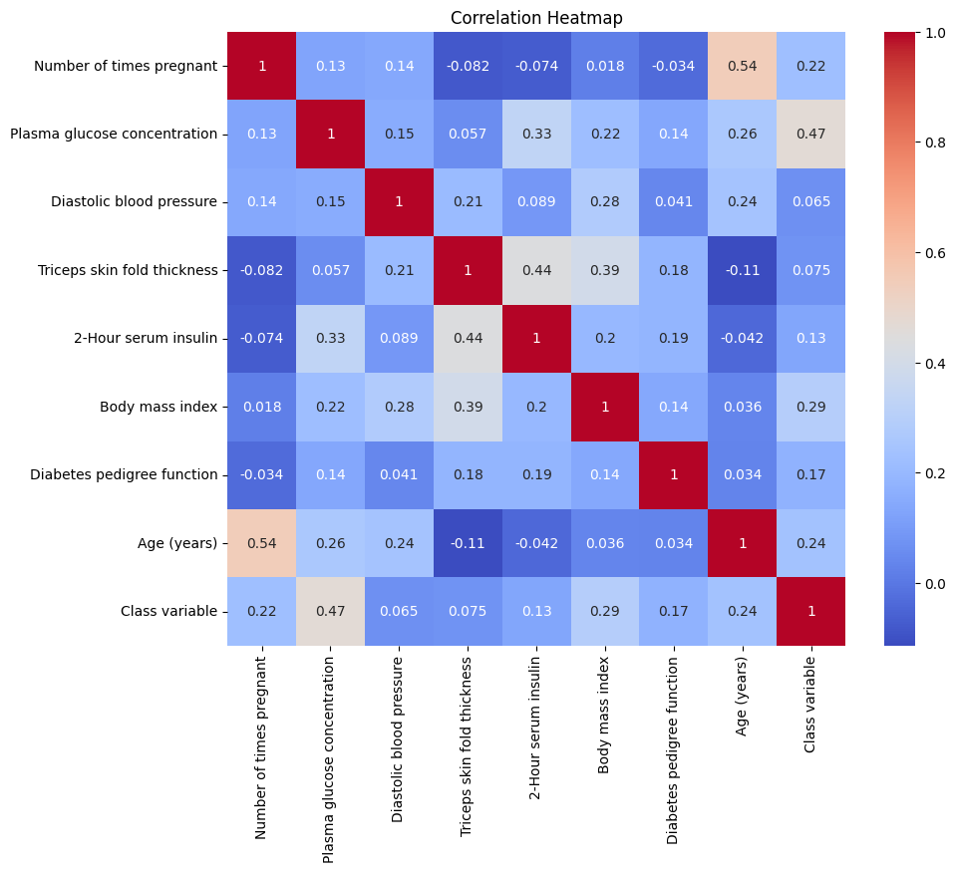

Decision Tree Accuracy
74.68 %

Naive Bayes Accuracy
76.62 %

Neural Network Accuracy
74.68 %

Performance Metrics
Accuracy : 74.68 %
Precision: 63.33 %
Recall : 69.09 %
F1 Score : 66.09 %

Classification Report
precision recall f1-score support

0 0.82 0.78 0.80 99
1 0.63 0.69 0.66 55

accuracy 0.75 154
macro avg 0.73 0.73 0.73 154
weighted avg 0.75 0.75 0.75 154

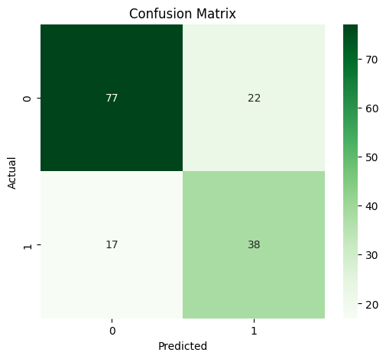
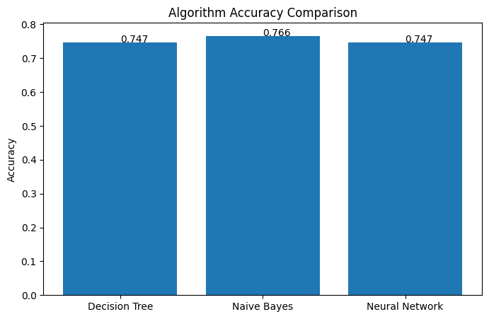

Important Clinical Attributes
Feature Importance
1 Plasma glucose concentration 0.314225
5 Body mass index 0.170700
2 Diastolic blood pressure 0.147679
7 Age (years) 0.099215
6 Diabetes pedigree function 0.083282
4 2-Hour serum insulin 0.066253
3 Triceps skin fold thickness 0.061164
0 Number of times pregnant 0.057482
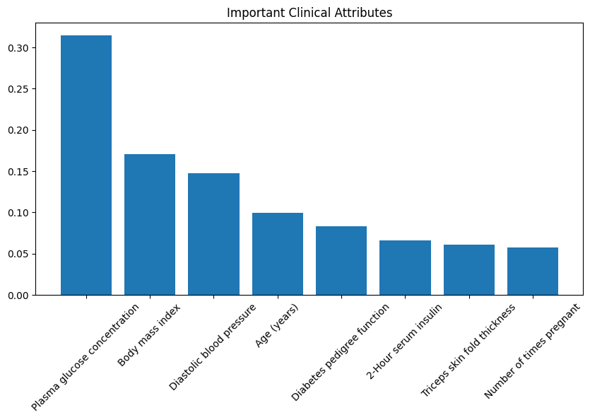

Patient Risk Prediction
Predicted Risk Category : LOW RISK

===================================
MODEL COMPARISON
===================================
Decision Tree : 74.68 %
Naive Bayes : 76.62 %
Neural Network: 74.68 %

Best Accuracy: 76.62 %
===================================
/usr/local/lib/python3.13/dist-packages/sklearn/utils/validation.py:2739: UserWarning: X does not have valid feature names, but StandardScaler was fitted with feature names
warnings.warn(

10. Reflection
Reflection
This assignment provided valuable practical experience in applying Machine Learning concepts to a real-world healthcare problem. Through the development of the Intelligent Healthcare Diagnosis and Patient Risk Prediction System, I gained a better understanding of how healthcare data can be processed and analysed to identify meaningful patterns.
The implementation of concept learning, including version spaces, candidate elimination, inductive bias, and heuristic search, improved my understanding of how Machine Learning systems learn hypotheses from training examples. Decision Tree learning provided experience in generating understandable decision rules and identifying important clinical attributes.
The implementation of Perceptron and Multilayer Perceptron models helped me understand neural network architecture, forward propagation, backpropagation, weight updating, and model training. Bayesian learning improved my understanding of probability-based classification using Bayes theorem and Maximum Likelihood Estimation.
A major learning outcome was the application of Genetic Algorithms for feature selection and optimization. This demonstrated how evolutionary computing techniques can search for effective solutions within a large hypothesis space.
Challenges faced during the assignment included preprocessing healthcare data, handling missing values, selecting suitable clinical features, training multiple Machine Learning models, and comparing their performance. These challenges improved my problem-solving and analytical skills.
The project is relevant to SDG 3 because it supports intelligent healthcare and early risk identification. It supports SDG 9 through the application of innovative Machine Learning technologies and SDG 10 by demonstrating the potential of intelligent systems to improve access to healthcare decision-support technologies.
Overall, this assignment enhanced my knowledge of Machine Learning, healthcare data analysis, neural networks, Bayesian learning, genetic algorithms, model evaluation, and intelligent decision-support systems.
.
11. References
[1] M. Ahsan, “Advancements in medical diagnosis and treatment through machine learning: A review,” Expert Systems, 2024, doi: 10.1111/exsy.13499.
[2] M. Badawy, N. Ramadan, and H. A. Hefny, “Healthcare predictive analytics using machine learning and deep learning techniques: A survey,” Journal of Electrical Systems and Information Technology, vol. 10, art. no. 40, 2023.
[3] H. Abdulazeem, S. Whitelaw, G. Schauberger, and S. J. Klug, “A systematic review of clinical health conditions predicted by machine learning diagnostic and prognostic models trained or validated using real-world primary health care data,” PLOS ONE, vol. 18, no. 9, 2023, Art. no. e0274276.
[4] T. Liu, A. Krentz, L. Lu, and V. Curcin, “Machine learning based prediction models for cardiovascular disease risk using electronic health records data: Systematic review and meta-analysis,” European Heart Journal – Digital Health, vol. 6, no. 1, pp. 7–22, 2024.
[5] K. Kolasa, B. Admassu, M. Hołownia-Voloskovaa, K. J. Kędzior, J.-E. Poirrier, and S. Pernic, “Systematic reviews of machine learning in healthcare: A literature review,” Expert Review of Pharmacoeconomics & Outcomes Research, 2023.
.

